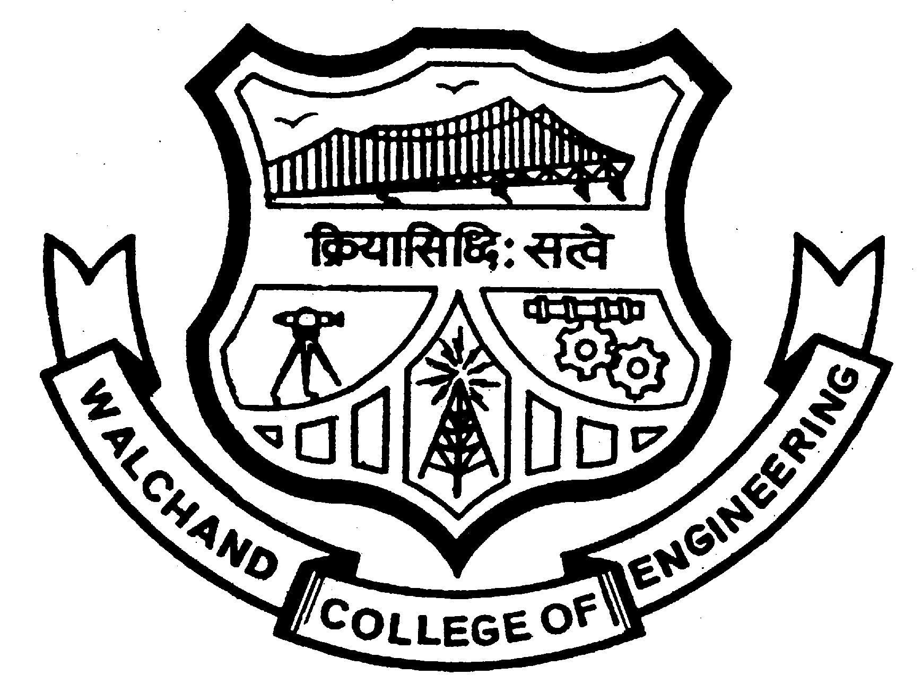
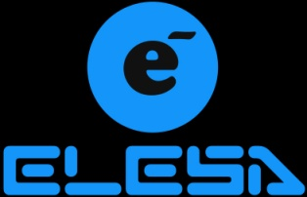
Walchand College of Engineering, Sangli.
ELESA
Electronics Engineering Students’ Association
Staff Advisor
Mrs.P.N.Savagave

President
Nikhil Malpani
president@elesa.in

Vice-President
Nikhil Magdum
vicepresident@elesa.in

Event Director
Pravin Dhongade
Mayuri Powar
event@elesa.in

Technical Director
Aman Maldar
technical@elesa.in

Club Service Director
Akshata Patil
Payal Jaju
csd@elesa.in

Program Director
Persis Sodawaterwalla
Aditi Patil
pd@elesa.in

Editor & Web Developer
Harshal Kulkarni
Neha choudhari
editor@elesa.in

Treasurer
Trupti Dinde
treasurer@elesa.in

Aptitude Developer
Tanvi Nagarale
Sameer Mhaiskar
aptitude@elesa.in

Date-
To
Dr. U. A. Dabde
OSD,
Students Welfare,
W.C.E., Sangli.

Subject: Permission for campaigning of the mega-event ‘ELECTROVERT’ of ELESA.
Respected Sir,
On 21st and 22nd September 2013, ELESA is organizing a two day mega event ‘ELECTROVERT’ in our college.
So, please grant us the permission for the campaigning of our event. For campaigning we would be requiring a counter, displaying our poster on the notice board and announcements in the classrooms.
ELECTROVERT comprises of many different technical and non-technical competitions related to the different engineering fields. It will surely help the students in not only developing their technical skills, but also in dynamically shaping their personalities.
Also, we assure you that our presence will not cause any hindrance to the academic works of the college.
Yours sincerely,

Staff Advisor President Mrs. P. N. Savagave Mr. Nikhil Malpani
Approved By,

OSD
Dr. U. A. Dabde

